**Excel Assignments - 7**

1. **Using Insert Function, give examples of any function available in the different dropdowns present in the function library. For example, AutoSum, Recently Used, Text, Date & Time, etc.**

The use of the Insert Function dialog box to help us insert the correct formula and arguments for our needs.

AutoSum Function

Select a cell next to the numbers we want to sum:

To sum a column, select the cell immediately below the last value in the column.

Click the **AutoSum** button on Formulas tab.

Press the Enter key to complete the formula.

Now, we can see the calculated total in the cell, and the SUM formula in the formula bar:

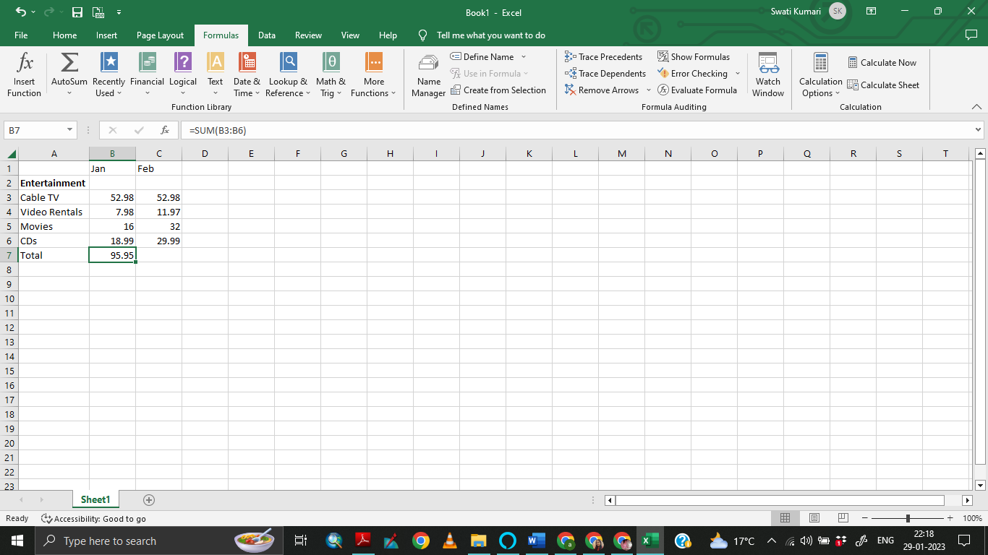

**2. What are the different ways we can select columns and rows?**

Let’s have a dataset as shown below and we want to select an entire column (say column C).

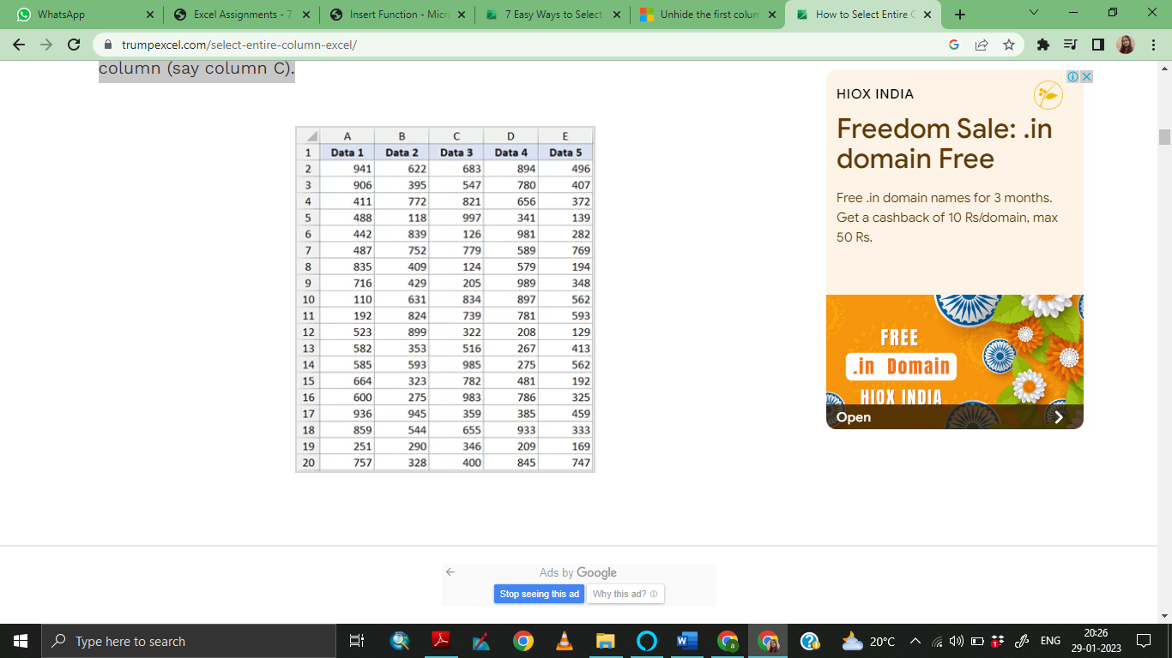

The first thing to do is select any cell in Column C. Once we have any cell in column C selected, use the below keyboard shortcut:

CONTROL + SPACE

Hold the Control key and then press the spacebar key on our keyboard. The above shortcut would instantly select the entire column.

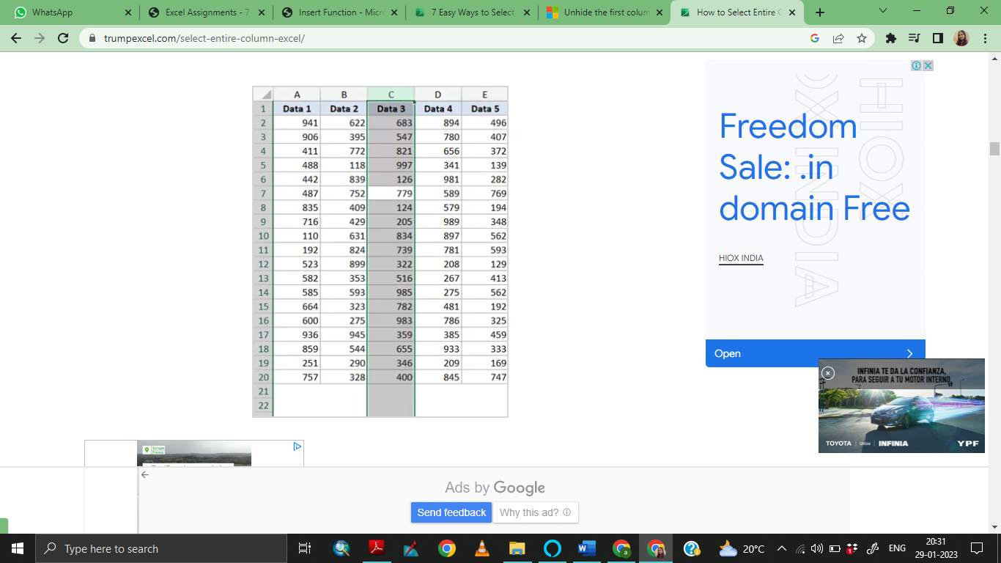

To select the Entire Row:

If we want to select the entire row, select any cell in the row that we want to be selected and then use the below keyboard shortcut

SHIFT + SPACE

Hold the Shift key and then press the Spacebar key. We will again see that it gets selected and highlighted in Gray.

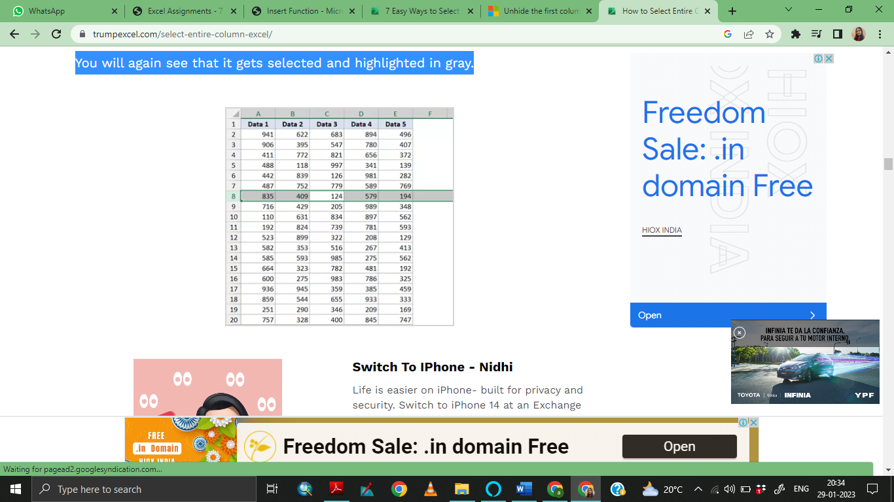

To select One Column (or Row)

If we want to select an entire column (say column D), hover the cursor over the column headers (where it says D). We will notice that the cursor changes to a black downward-pointing arrow.

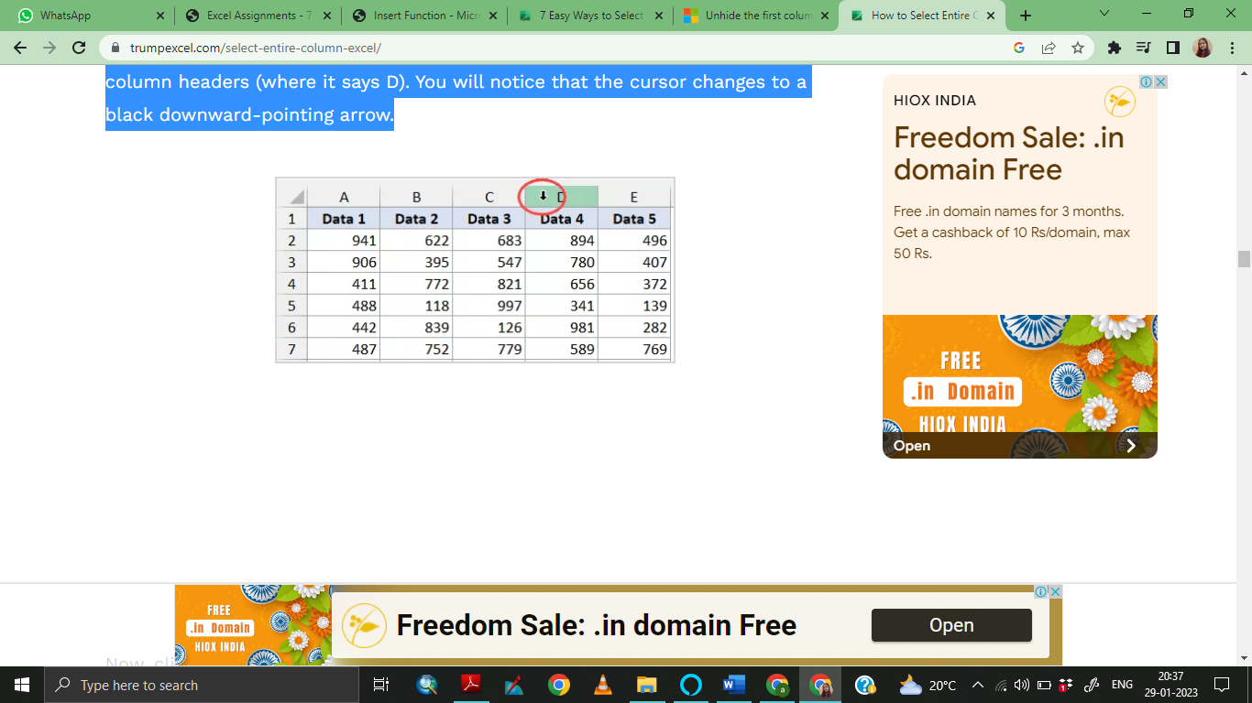

Now, click the left mouse key.

Doing this will select the entire column D.

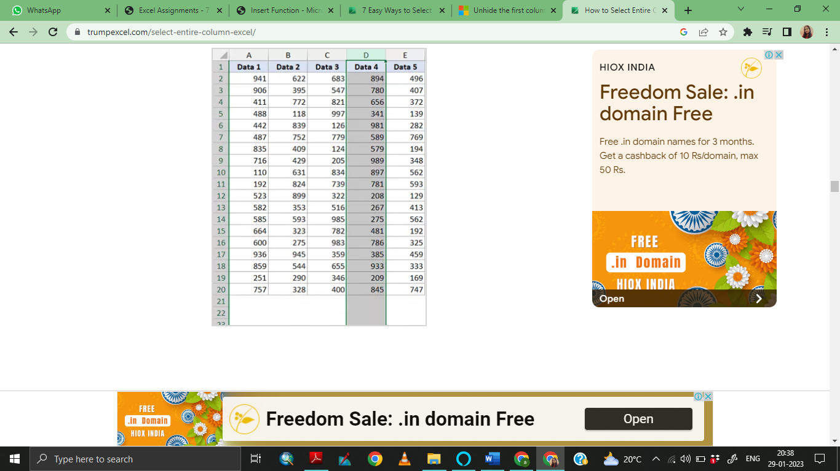

Similarly, if we want to select the entire row, click on the row number (in the row header on the left).

**3. What is AutoFit and why do we use it?**

AutoFit is Excel's feature which is designed to automatically resize cells in a worksheet to accommodate different sized data without having to manually change the column width and row height.

AutoFit Column Width - changes the column width to hold the largest value in the column.

AutoFit Row Height - adjusts the column width to match the largest value in the row. This option expands the row vertically to hold multi-line or extra-tall text.

AutoFit is a feature in Excel that lets we easily change the size of one or multiple columns or rows on a spreadsheet. It helps we make sure that all the data in every cell group is clearly visible. Without AutoFit, we would have to manually alter each column or row by clicking on and holding its right or lower border and dragging it to our intended size or putting in specific measures for width or height.

Unlike column width, Microsoft Excel changes the row height automatically based on the height of the text we type in a cell; therefore, we won't really need to auto fit rows as often as columns. However, when exporting or copying data from another source, row heights may not auto adjust, and in these situations the AutoFit Row Height opting comes in helpful.

**4. How can you insert new rows and columns into the existing table?**

Use Insert to add a row .

To insert a row, pick a cell or row that's not the header row, and right-click. To insert a column, pick any cell in the table and right-click.

Point to Insert and pick Table Rows Above to insert a new row, or Table Columns to the Left to insert a new column.

If you're in the last row, you can pick Table Rows Above or Table Rows Below.

In the example shown below for rows, a row will be inserted above row 3.

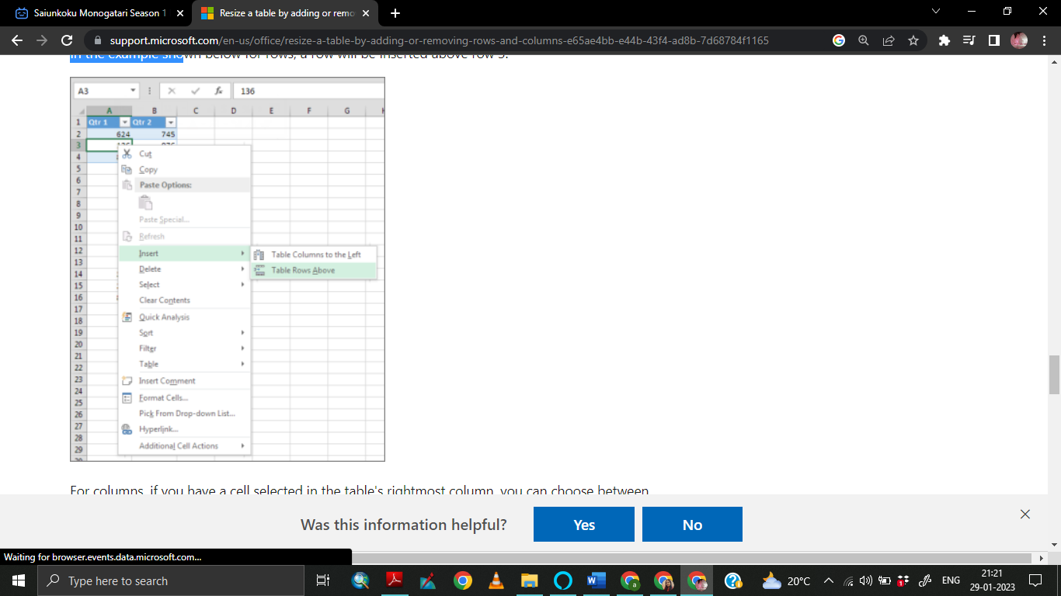

For columns, if you have a cell selected in the table's rightmost column, you can choose between inserting Table Columns to the Left or Table Columns to the Right.

In the example shown below for columns, a column will be inserted to the left of column 1.

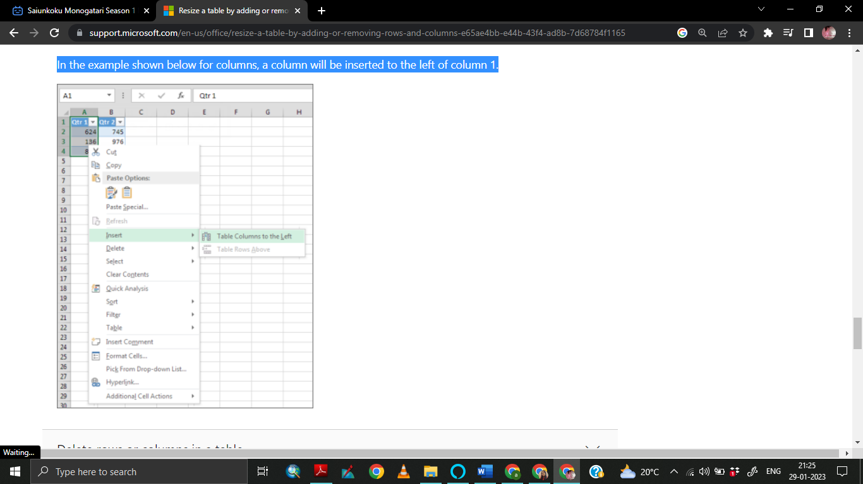

**5. How do you hide and unhide columns in excel?**

To hide a column, execute the following steps.

1. Select a column.

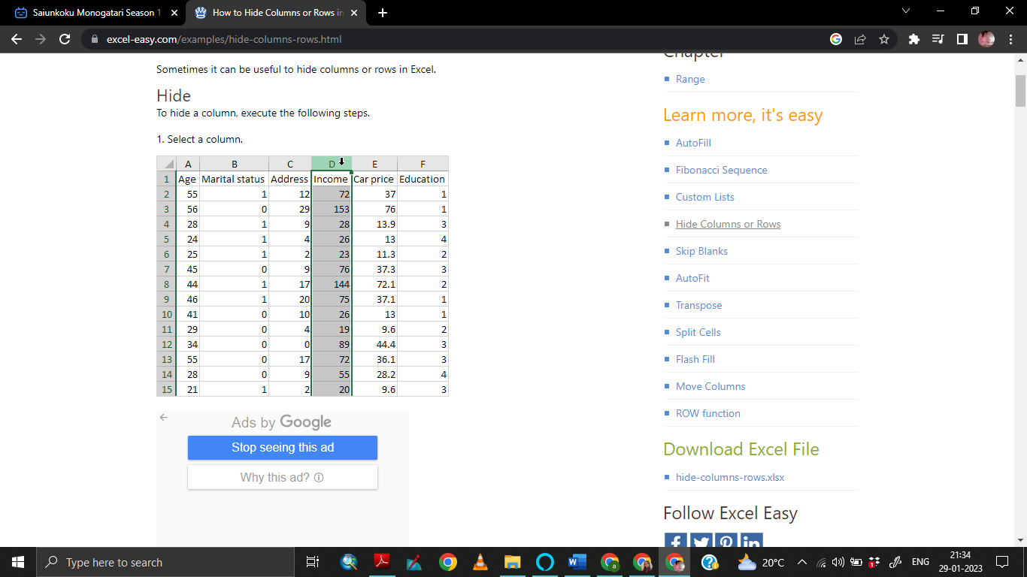

2. Right click, and then click Hide.

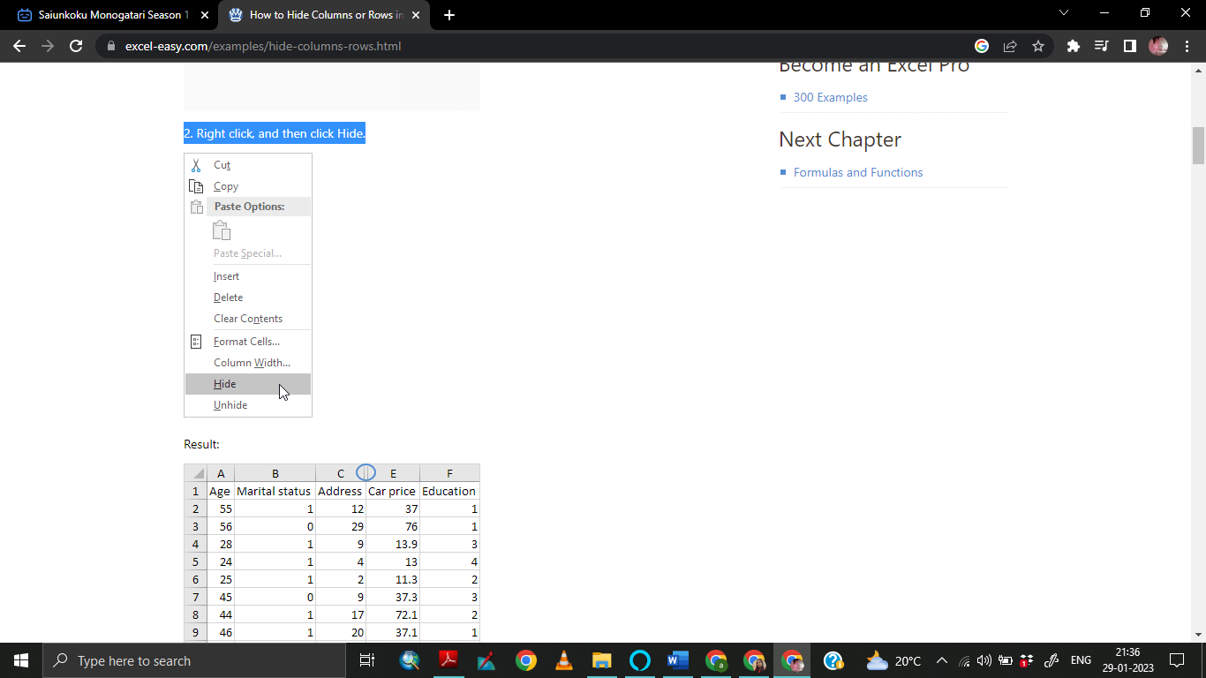

Result

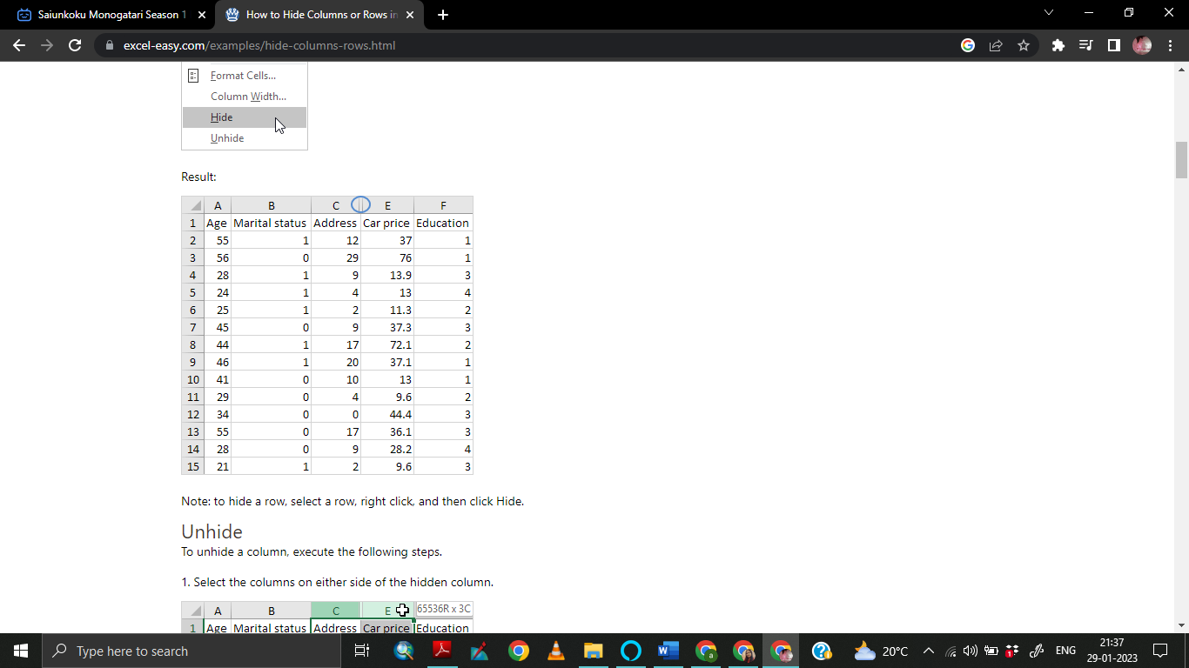

To unhide a column, execute the following steps.

1. Select the columns on either side of the hidden column.

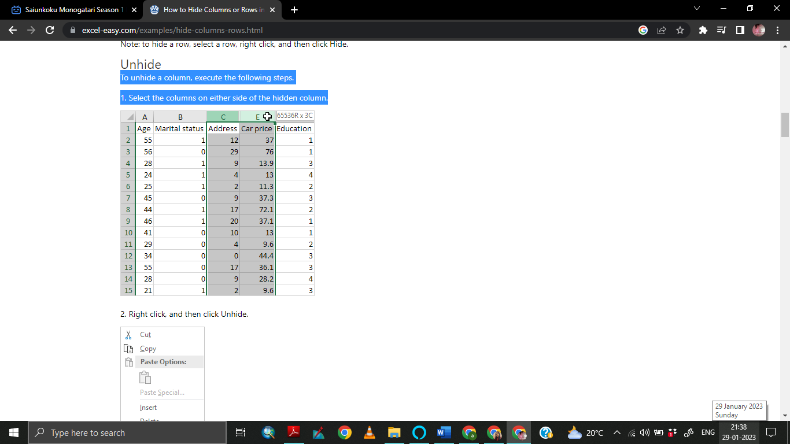

2. Right click, and then click Unhide.

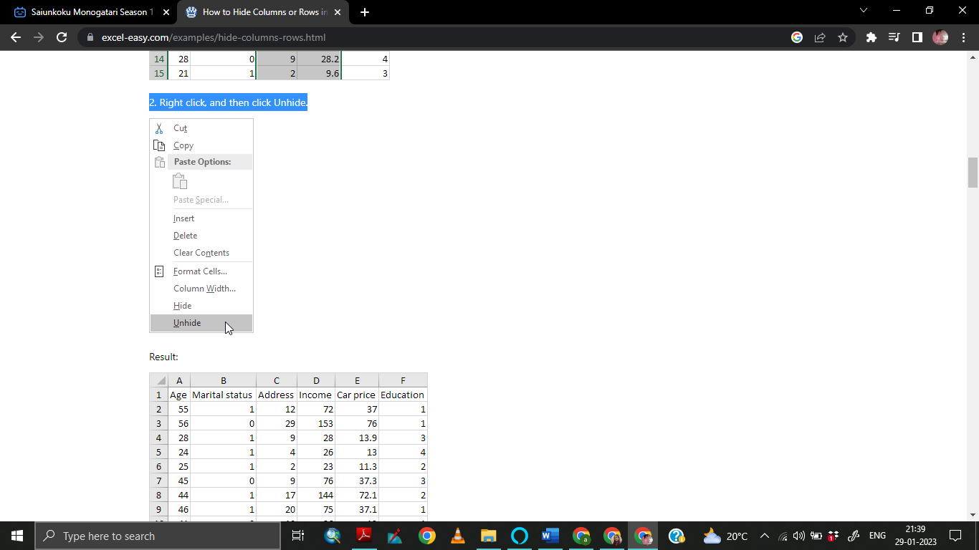

Result

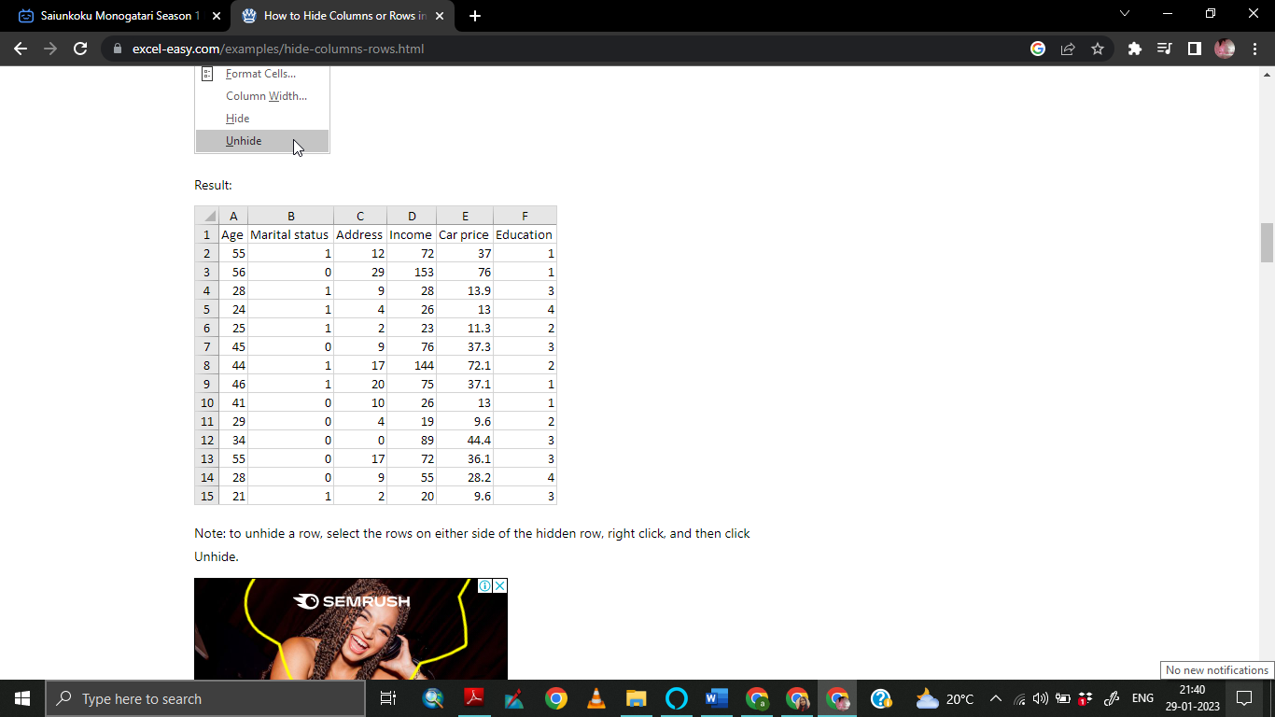

**6. Create an appropriate table within the worksheet and use different functions available in the AutoSum command.**

AutoSum is a special tool in Excel that allows you to quickly calculate the SUM of numbers within a worksheet. One can access the AutoSum button from the Home – Editing group or Formulas – Function Library group. By clicking the little arrow on the right of the AutoSum button, you can access many other types of functions, such as AVERAGE, MAX, MIN, and COUNT.

Use of the SUM function.

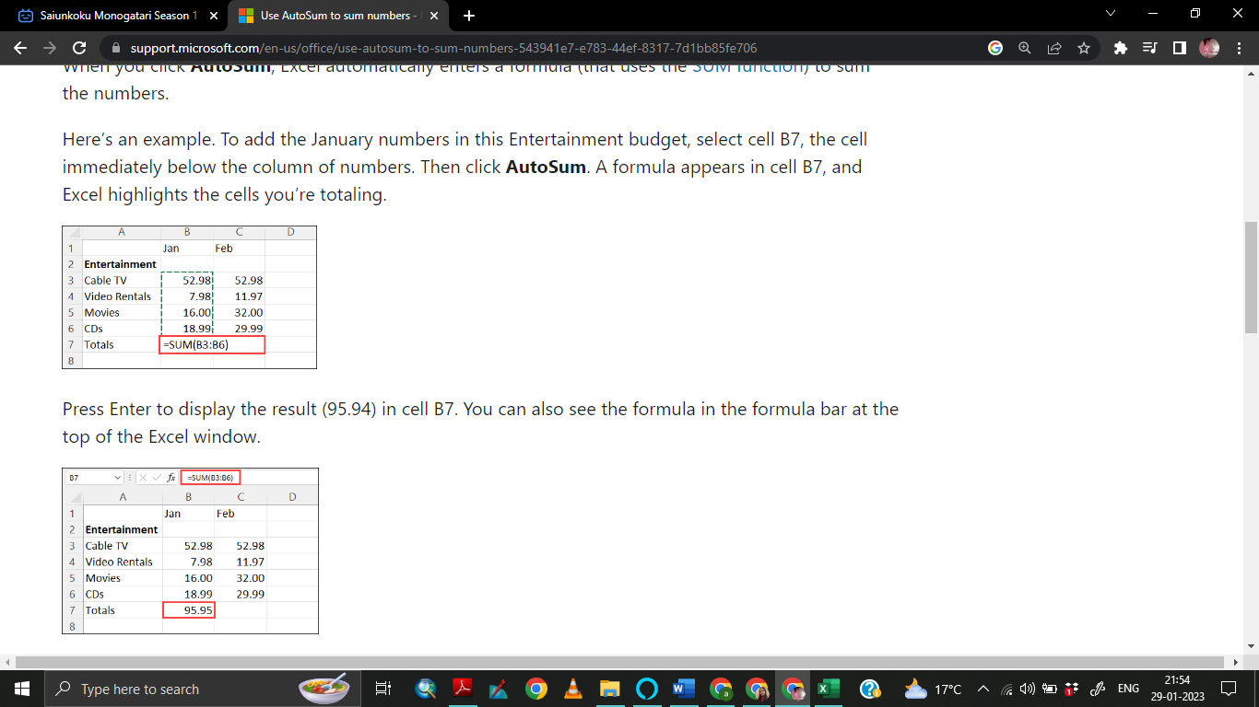

Use of Average function

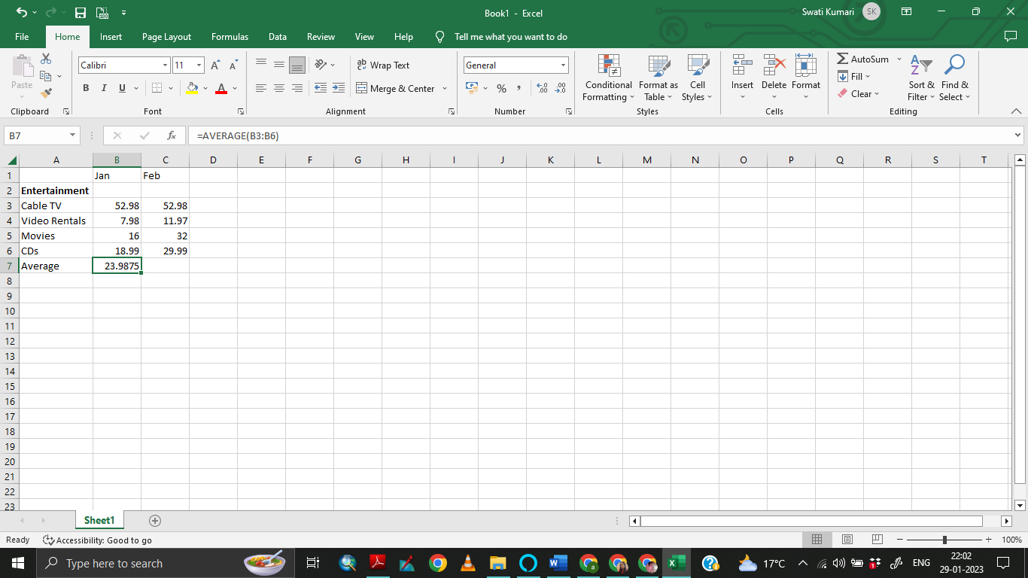

Use of Total Number function

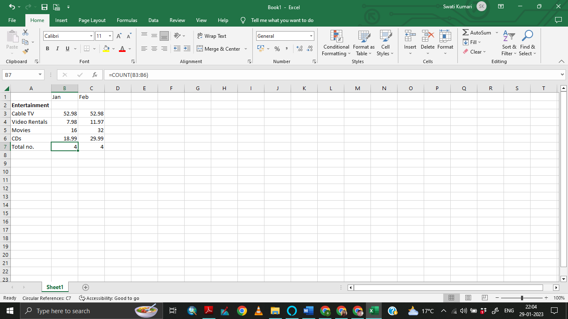

Use of Maximum and Minimum function

